High Expectations for Spain in the 2026 World Cup!
By: Leonardo Tello

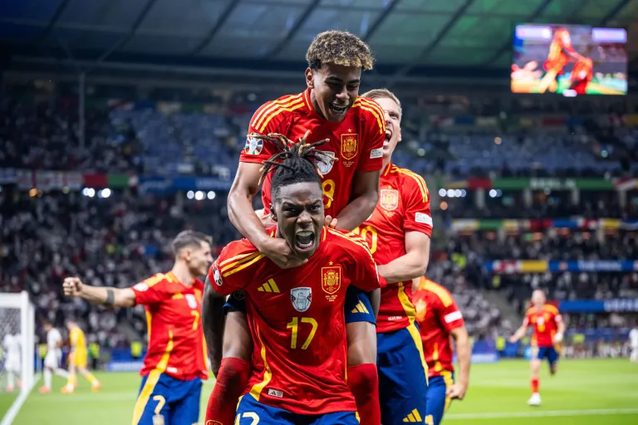
With the 2026 FIFA World Cup approaching in North America, expectations are high for the Spain national football team. After a recent victory in the “Eurocopa” and a rising generation of talented players, many fans and analysts believe Spain could lift football’s most prestigious trophy for the second time in its history.

Spain’s confidence going into the tournament comes from its strong squad and recent performances. The team has key players such as Rodri and Pedri, who help control the rhythm of the game and keep possession of the ball. Their style of play is often linked to the famous tiki-taka approach, which focuses on short passes, movement, and patience in attack.

Another reason for the optimism is the rise of young players like Lamine Yamal and Nico Williams, whose speed and creativity bring energy to Spain’s attack. Under head coach Luis de la Fuente, Spain is likely to play in a 4-3-3 formation that allows the team to control possession while attacking from both wings. Analysts have also highlighted Spain’s potential on the international stage. “Spain has the talent and depth to compete with any team in the world,” said analyst Robbie Dunne from Opta Sports. “If the young players continue to improve, this squad has a real chance of winning the World Cup.”

However, high expectations also bring pressure. Spain has struggled in recent World Cups despite entering tournaments as one of the favorites, and the team has not reached the quarterfinals since winning the 2010 FIFA World Cup. Some experts believe Spain still needs a more consistent goal-scoring striker to compete against the world’s strongest defenses, although players like Ferran Torres have recently been used in that role.

As the 2026 tournament gets closer, excitement around Spain’s national team continues to grow. With a talented squad, a clear playing style, and several promising young stars, expectations are higher than ever. Whether Spain can turn that promise into another historic World Cup victory will be decided on football’s biggest stage in 2026.

Sources

- Gualtieri, Thomas, et al. “‘Football Is Seldom Ever Just about Sports’—This Year’s European Championship Demonstrated How Waves of Immigration Have Redefined Sports.” Fortune Europe, Fortune, 15 July 2024, fortune.com/europe/2024/07/15/this-years-european-championship-demonstrated-how-waves-of-immigration-have-redefined-sports-spain-england/.

- Dunne, Robbie. “Why Are Spain Favourites to Win the 2026 World Cup? | Opta Analyst.” Opta Analyst, 5 Dec. 2025, theanalyst.com/articles/spain-2026-world-cup-favourites-opta-supercomputer. Accessed 15 Mar. 2026.

